evaluation report on:

evaluation of impact and effects of implementation of
Operational Programme on Transport 2007-2013

Contract NoD-4/06.02.2020 „Evaluation of the impact and effects of the implementation of Operational Programme “Transport” 2007-2013 and evaluation of the progress under Operational Programme “Transport and transport infrastructure” 2014-2020 and contribution to the EU Strategy”

December, 2020
Sofia

INTRODUCTION

The current evaluation report has been prepared under Contract No D-4/06.02.2020 with subject „Evaluation of the impact and effects of the implementation of Operational Programme on Transport 2007-2013 and evaluation of the progress under Operational Programme on Transport and Transport Infrastructure 2014-2020 and its contribution to the EU Strategy”, with Contracting Authority – Bulgarian Ministry of Transport and Information Technology and Communications and Contractor - Consortium "European Evaluations".
The report covers evaluation of the impact and effects of the implementation of Operational Programme on Transport 2007-2013.
OPT is one of the seven operational programmes implemented in the Republic of Bulgaria within the programming period 2007-2013, financed by the European Regional Development Fund, the EU Cohesion Fund and the State Budget of the Republic of Bulgaria. The overall goal of the programme was development of sustainable transport system and its specific goals were the integration of the national transport system into the EU transport network of and achievement of balance between transport modes.
The main objective of current impact evaluation is to study and analyze the effects achieved by the projects implemented in the programming period 2007-2013, to assess project effectiveness and efficiency and to improve decision making process covering strategic problems and challenges in transport sector and the country as a whole. The evaluation was carried out between 06.02.2020 and 08.09.2020 using a methodology covering the main evaluation aspects– relevance, consistency, effectiveness, efficiency and impact.
The evaluation scope includes the following evaluation questions (EQ):
- Is there a difference with the intervention? How have investments led to change?
- What/how much is the contribution of the intervention? Is there added value of the intervention?
- In view of modifications of OPT 2007-2013, was the programme effectively working within the new context and if so, why?
- What degree of integration into the European transport network has been achieved by the national transport system?
- How has accessibility to settlements improved as a result of the projects implementation?
- Is transport infrastructure less busy and was a balance between different transport modes achieved?
- What are the economic and environmental benefits and effects for the transport sector?
- What is the contribution of OPT to sustainable development policy?
- What were the main problems encountered in the process of preparation and implementation of projects?
The conclusions are based on documentary analysis, financial, economic and statistical analysis and Evaluator's own studies – performed surveys based on standardized questionnaires, in-depth interviews with stakeholders and expert meetings with representatives of the MA.
The results of the evaluation can be used within future preparation and implementation of operational programmes in transport sector during subsequent programming periods to ensure most effective and efficient policy implementation.
An extended version of the evaluation is presented in Annex No 3 to this report.

SUMMARY
Operational programme on Transport was implemented in programming period 2007-2013, funded by the European Regional Development Fund, the EU Cohesion Fund and the state budget of the Republic of Bulgaria. The overall goal of the programme was development of sustainable transport system and its specific goals were the integration of the national transport system into the EU transport network of and achievement of balance between transport modes. The total amount of funds invested in the form of grants under the programme is appr. EUR 3,685 million or 98.58% of the programme budget. Support was provided for 120 projects, with main share focused on 25 investment projects, 11 of which were "major projects" (with budget over EUR 50 million), as per the meaning of Regulation (EC) No 1083/2006. As a result of the programme implementation, 345 km of railway were rehabilitated on the territory of the Republic of Bulgaria, 310 km roads were built, 21 km metro lines and 20 metro stations were constructed.

The main objective of the impact assessment of the OPT is to identify and analyze the achieved effects of the projects implemented in programming period 2007-2013, to assess programme effectiveness and efficiency, to evaluate the programme contribution to solving strategic problems and overcoming challenges in the transport sector and the national economy.

The evaluation was carried out in the period 06.02. 2020 – 08.09.2020 according to a methodology covering the main programme characteristics – relevance, consistency, effectiveness, efficiency and impact. The conclusions of the evaluation are based on documentary review, financial, economic and statistical analysis and the Evaluator's ad-hoc research – questionnaires, in-depth interviews with stakeholders and expert meetings with representatives of the MA. The approaches applied in the evaluation are based on established good practices in the EU, in order to ensure the accuracy, consistency, transparency, independence and reliability of evaluation results.

Recommendations
Conclusions
Findings
Analysis
Data

The results of the evaluation can be used in the preparation and implementation of operational programmes in the transport sector during subsequent programming periods, in order to ensure effective and efficient implementation of the policies implemented.

Main findings

The programme has achieved very good financial and physical implementation rates. The total financial implementation rate is 98.6%. The majority of product and output indicators report achievement rates above 90% of their targets. The targets were not met only for result indicator "value of time saved" on roads and railways, due to the lower levels of reported traffic than expected.

Net effects of the OPT interventions

The net impact of the OPT implementation is positive, and the most tangible effects are seen on the labor market (employment and wages), on the real GDP, on exports of goods and services, on private consumption, as well as on public/private investment. The most significant effects are the result of the projects implementation in the road sector, followed by the ones related to railway, and the ones for the extension of Sofia Metro. Overall, the OPT impact is mostly seen in the regions of Southern Bulgaria, and in the Southeastern and Southwestern planning areas in particular. On the one hand, that is due to the relatively higher amount of money invested in this region. On the other hand, it owes to the positive impact on the business environment of some key projects in the Southeastern region. The impact in Northern Bulgaria is weaker, and the smallest effects observed are in the Northwestern and the Northeastern regions.
Performance assessments and analysis of the impact on macroeconomic development undoubtedly show that infrastructure projects play an essential role in improving the competitiveness of the Bulgarian economy. Thus, these projects lead to higher economic growth and to the improvement in the quality of life of the country’s population. The efficiency analysis on investments made shows that product performance has been achieved at significantly lower average costs than the respective EU ones.

Contribution to sustainable development and benefits achieved

OPT demonstrates a high level of coherence with the strategic objectives and guidelines for development of transport policy at EU level, both at the initial programming stage and after the programme modifications. The implementation of railway and urban transport projects has contributed to diversion of road traffic, reduction of private vehicles and carbon emissions. The contribution of OPT projects to environmental protection has been justified by the environmental benefits generated by these projects.

Figure I-1: Results achieved, net effect on real GDP and mechanism of impact of the OPT on the macroeconomic environment
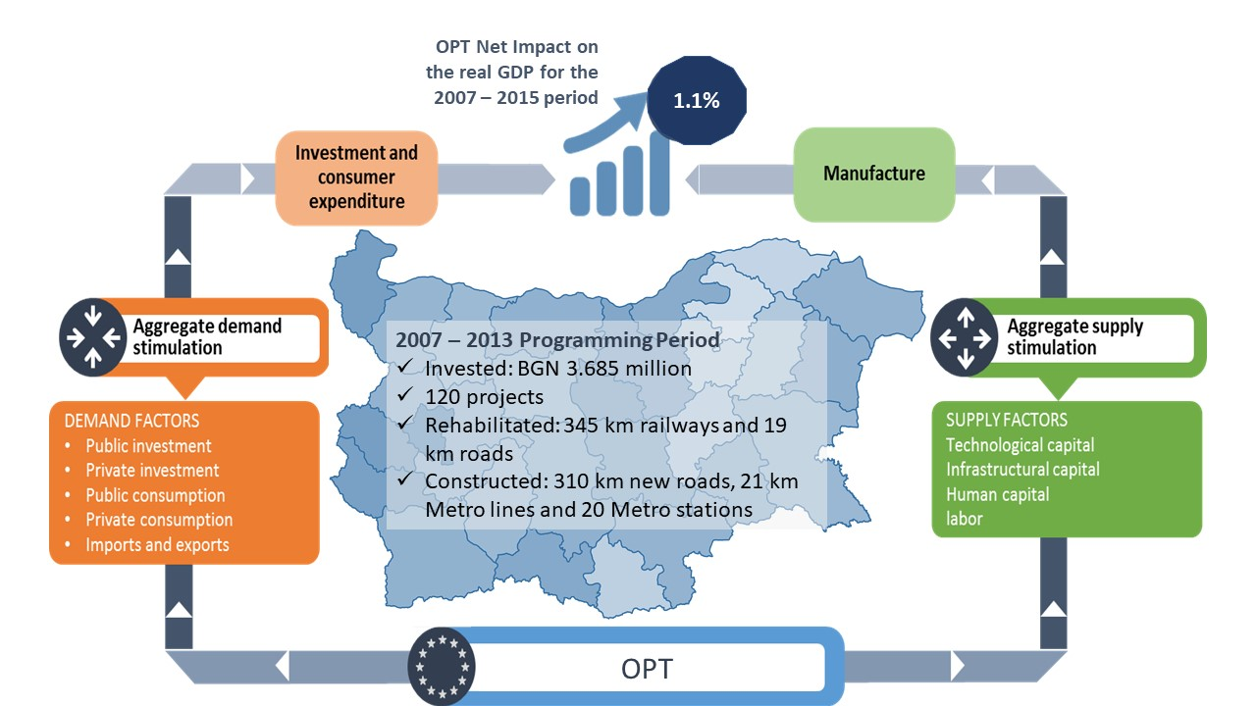

Source: Final report on the implementation of the PT, own calculations

The assessed effects indicate a relatively large impact of the programme on the overall improvement of the macro environment. The most significant economic benefits are in two directions – on the labor market and on investment activity. The economic effects on the transport sector are also positive. Within the economic benefits from the implementation of major projects assessed through CBA, a predominant share belongs to the benefit of time saved (approximately 70% of the benefits), followed by the benefit of the reduced number of transport accidents, and the benefits related to reducing negative environmental impacts.
The realized benefits of the projects were assessed through a retrospective cost-benefit analysis of case studies in the framework of the evaluation. This method has resulted in a comparison of the results in the exploitation phase with the projected benefits. Most projects have a high degree of achievement of the economic benefits (over 30%). The railway projects and one of the metro extension projects have the lowest coefficient ratio for achievement of benefits, due to the lower reported traffic than forecasted volumes (passengers and freight). In road sector the reported traffic volumes are close to the forecasted, so it can be assumed that the economic benefits have been achieved to a high extent.
According to the results of the CBAs, environmental impact related to the reduction of carbon emissions and to climate change has a net positive value within railway projects and the extension works for Sofia Metro. Most of road projects have a negative overall environmental effect. Measures to reduce detrimental impact on environment have been ensured through environmental legislation both at programme and project level. The monitoring of implemented measures was carried out through regular reports on the monitoring and control of OPT environmental impact and the General Transport Master Plan. These reports have shown that the envisaged measures have been respected to a great extent and that eco-friendly infrastructure was built where applicable.

Programme modifications
Programme modifications have proven to be an effective measure for addressing delays in implementation, applying corrective measures to high-risk projects and preventing loss of funds. Through modifications certain high-risk projects have been excluded from the programme and new projects were included, which contributed to prevent the loss of funds, while respecting the objectives and priorities of the programme. Some of the excluded projects were situated in the Northwestern Planning Region, which was a reason for concentrating the positive territorial effects of the program in Southern Bulgaria. The modifications resulted in higher budget for multimodal transport projects, including metro expansion and intelligent transport systems, and lower budget for railways and national roads.

Integration of the national transport system into the European transport network
The achievement of the integration of Bulgaria's transport network into that of the EU has been enshrined as a strategic objective of the national transport policy. The integration of the national transport system into the common European transport market has been seen as a favorable opportunity for the development of the sector. Under OPT, 25 investment projects totaling BGN 3.922 billion were implemented, of which almost 2/3 were for projects on TEN-T network. Directing most of the OPTs financial resources to these projects was a necessary prerequisite for integrating the national transport network into the TEN-T network.
The evaluation included analysis of the degree of integration in terms of achieving physical connectivity with TEN-T in neighboring countries and achieving compliance with the technical requirements for the TEN-T type concerned to ensure interoperability. The results show that the programme had a significant contribution to achieving physical connectivity on the rail and road network. In assessing the technical requirements for ensuring interoperability for the rail network, some inconsistencies were identified with regard to the European Rail Traffic Management System, as well as the speed and length requirements of trains. In the road sector, it is recommended to encourage the construction of safe and secure car parks. To achieve more tangible impact of investment, it is essential to complete construction of the whole rail and road lines in the near future.

Workload and balance of transport infrastructure
European transport policy is oriented towards increasing the efficiency of the transport system, which is achieved by making effective use of the available infrastructure and efficiently investing in a new or modernized one.
The highest effectiveness and efficiency rates have been observed in projects where capacity is increased but the load rate is higher than the original due to the increase in traffic; this is an indicator of a very good economic return on invested funds and justified project selection. These results have been observed in the projects for construction of new metro lines, as well as the road project Kardzhali – Podkova.
Good levels of effectiveness have been observed in projects showing an increase of traffic levels, but lower workload of infrastructure than the baseline, due to the increased capacity. These results have been observed in the project for railroad Parvomai – Svilengrad, Phase 2 and railway line Plovdiv - Burgas, the road project for construction of Struma MW and SRR – Yana, followed by Trakia MW And Western Arc of SRR and Maritsa MW, as well as the Intermodal Terminal in Plovdiv. Low to medium level of effectiveness have been observed in projects where traffic remains at the same levels or even decreases. As of 2019, such projects are the railway line Septemvri – Plovdiv and the railway line Svilengrad – Turkish border.
To achieve tangible effects of investments in railway infrastructure, it is necessary to complete construction on the whole line in the next programming periods. It is recommended that performance assessments be carried out after the completion of the full sections of the road and rail network, including after implementation of the relevant phases in programming periods 2014-2020 and 2021-2027.

Territorial dimensions of OPT and accessibility
The majority of projects contribute to the construction of the TEN-T network in the country, which is important for Bulgaria as one of the EU members states with the lowest level of construction of this network. There has been an improvement in accessibility with neighboring countries - Greece and Turkey.
The most supported in terms of newly built road infrastructure (motorways) and rehabilitated and reconstructed railway lines are South Eastern and South-Central Regions. Minor support has been granted to Northern Bulgaria through the implemented bypass roads of Vratsa, Montana and Gabrovo. As a general conclusion, it can be noted that all the implemented linear projects have a positive impact for accessibility of territories which they cross, however they did not have significant contribution to national coherence and to overcoming the differences in infrastructure development in South and North Bulgaria. This is one of the reasons for higher economic growth and incomes in South Bulgaria, insofar as the better accessibility is important to development of regional economies.
The implemented projects improve cohesion within the territory of the regions through which they pass and the accessibility of the local population to the rest of the country and within the region. The projects have ensured improved connectivity, better mobility for labor journeys, access to health, education, cultural and other services, achieving intra-regional integration in planning areas and regions.
There has been an improvement in accessibility to key centers in Bulgaria - the centers of the first and second hierarchical levels – the cities of Sofia, Plovdiv, Stara Zagora, Burgas, Blagoevgrad, which are major growth boosters on the national territory.

Main problems and lessons learned
The main problems in the implementation of OPT have been related to the development and modification of the technical documentation, administrative procedures for land acquisitions and archaeological studies, public procurement procedures, lack of sufficient own resources of beneficiaries, contingency costs. Within the first programming period, typical problems arise due to lack of experience and capacity for management of infrastructure projects, as well as institutional and organizational problems. In some cases, these circumstances have led to exclusion of projects from the programme, or reduction of project scope, phasing-out of projects, completion of certain activities with beneficiaries' own resources, delays in implementation schedules.
The results of case studies carried out for 12 investment projects show that the majority of projects have met their objectives and target values of indicators. Some projects have reported exclusion of project activities, phasing out or completion with national funds. Delays in implementation were typical for railway projects and some road projects. The projects for metro extension how highest degree of overall effectiveness in terms of scope and implementation period. The delays in project preparation and implementation have been caused mainly by design problems, administrative procedures for land acquisition, public procurement and procedures under the Spatial Territorial Act, as well as procedures of archeological objects. The long periods for project preparation and implementation of major projects are typical not only to Bulgaria, but also to the EU.
In spite of the reported problems, the beneficiaries and the MA demonstrated good communication and cooperation for operational problem solving and risk management, aimed to prevent loss of funds and project failures. All measures within the competence of the MA and the beneficiaries have been taken, including legislative amendments to facilitate administrative procedures for the settlement of ownership of construction objects. As a result of these efforts, the programme has reported excellent levels of implementation.

