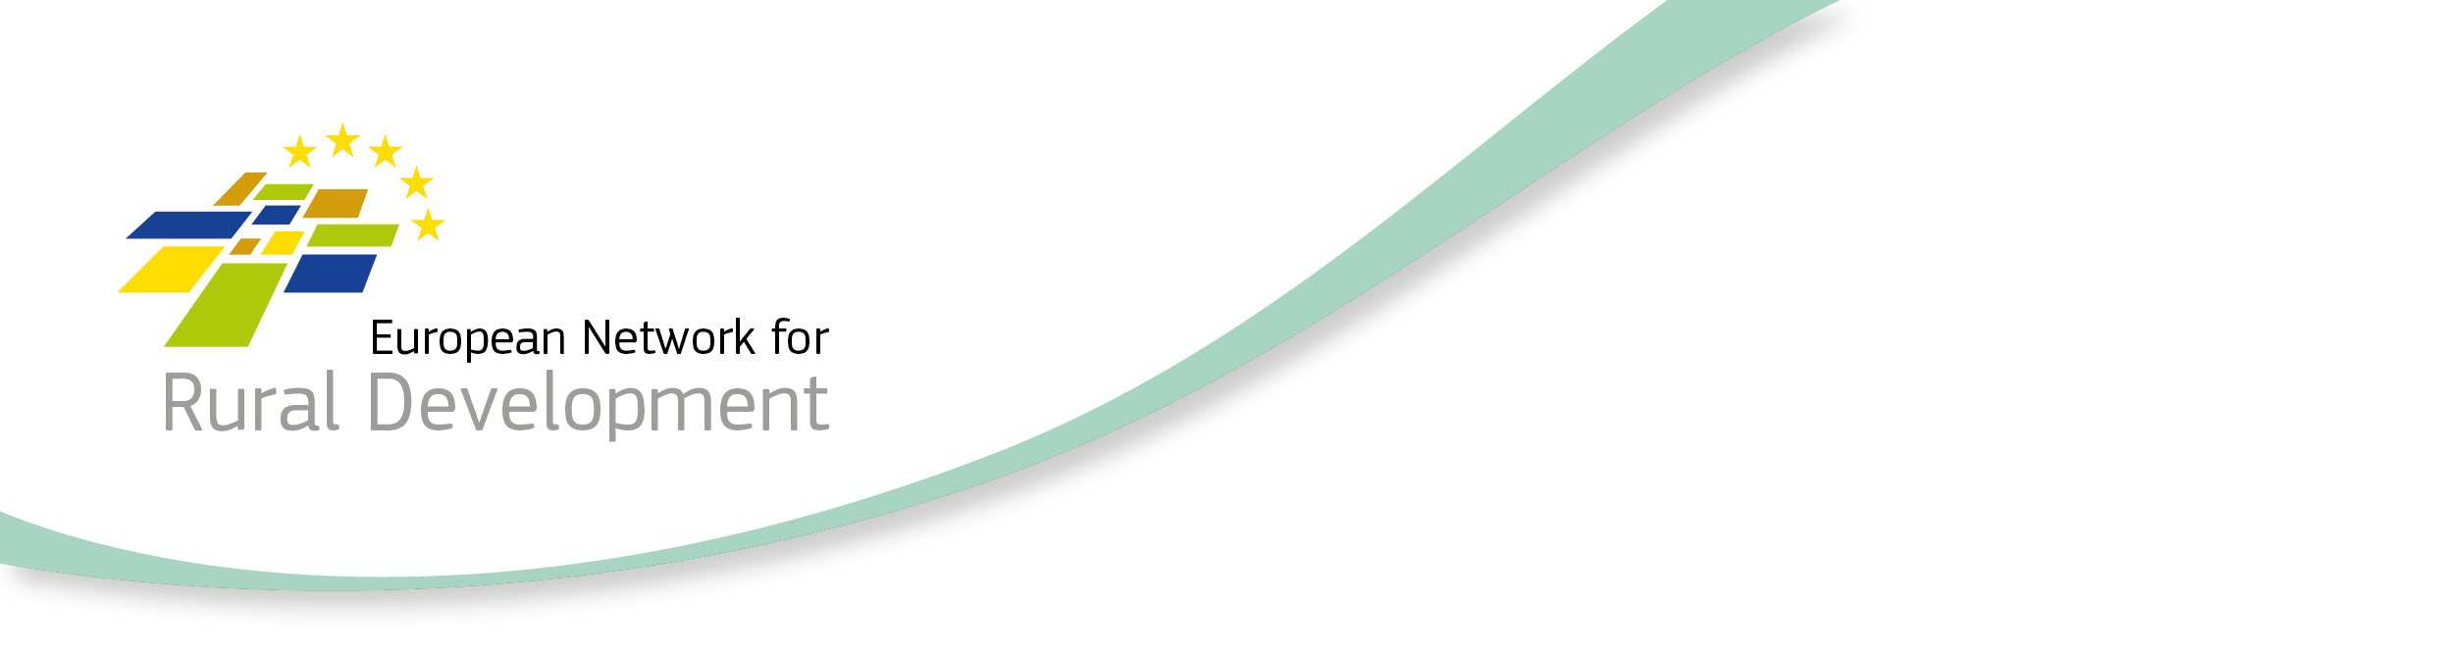

CLLD Cooperation OFFER

Title of the proposed project (English)
Ecological education, renewable energy sources, climate change and innovations

Type of project (select as many as you want)
Cooperation within the MS  ☐ Across regions  ☐ Within the same region | Transnational cooperation  ☒ Cross-border cooperation  ☒ With other MSs (no shared border)  ☐ Non EU countries | Sea basin cooperation  ☐ Mediterranean  ☒ Baltic  ☐ North Sea  ☐ Atlantic

Brief summary of the project idea (max 800 characters)
Raising the knowledge of the inhabitants of the area of LAG "Podkowa" and LAG "Przymierze Jeziorsko" in the field of ecology, environmental protection, renewable energy sources and climate change.

Looking for partner located in the following types of areas (select as many items as you want)
☒ National / Regional borders  ☐ Inland  ☐ Island  ☐ Lakes and rivers  ☐ Coastal  ☐ Mountainous | ☒ Rural  ☒ Peri-Urban  ☒ Urban  ☒ Small town  ☒ Historic centre  ☒ Densely populated residential area  ☐ Segregated/deprived neighbourhood | ☐ Isolated / remote  ☐ Sea basin  ☐ Mediterranean  ☐ Baltic  ☐ North Sea  ☐ Atlantic

Looking for partner located in areas with the following assets (select as many items as you want)
☒ High Nature Value  ☐ Cropland  ☐ Pasture | ☐ Forest  ☐ Non-productive land  ☐ Industry | ☐ Presence of relevant cultural sites  ☐ Mineral extraction  ☒ Protected areas

Topic of the project (select up to 10 items)

☒ Innovation  ☒ Research & Development  ☒ New technologies  ☒ Knowledge transfer / education / training activities  ☐ Broadband / Internet / ICT  ☐ Culture and Cultural heritage | ☐ Built environment  ☒ Village, harbour renewal  ☐ Public / community spaces / green areas  ☒ Energy efficiency, retro fitting buildings  ☒ Reconversion brownfield areas  ☒ Rural infrastructures  ☐ Social inclusion / Public services  ☐ Integrated service delivery  ☐ Social services  ☐ Transport & Mobility  ☐ Education  ☐ Health  ☐ Housing  ☐ Anti discrimination  ☐ Social enterprises  ☐ Employment / job creation  ☐ Access to labour market  ☐ Work-private life reconciliation  ☐ Self-employment  ☐ Upskilling  Target groups:  ☐ Youth  ☐ Women  ☒ Long term unemployed  ☐ Homeless  ☐ Elderly  ☐ Migrants  ☐ Fishermen  ☐ Marginalised communities e.g. Roma  ☒ People with disabilities  ☐ Ex offenders  ☒ Others
☐ Agriculture & Farming
☒ Small farms
☐ Semi-subsistence farming
☒ Organic farming
☐ Livestock
☐ Animal welfare
☒ Young farmers
☐ Urban farming
☐ Fisheries and aquaculture
☐ Fisheries
☐ Aquaculture
☐ Forestry
☐ Food & Drink
☐ Marketing
☒ Supply chains / Producer organisations & Cooperatives
☐ Non-food products / Crafts
☐ Business development
☒ Economic diversification
☐ Tourism / Territorial branding
☐ Natural environment & Resources / Landscape
☐ Climate change mitigation / adaptation
☐ Local energy production / renewable energies
☐ Circular economy / bio, green economy
☐ Governance
☐ Community development
☐ Rural Urban linkages
Additional keywords: (up to 3)

Renewable energy sources

Objective
Initial position / background / local context of the proposed project (max 800 characters)
The starting situation or local context in which the projects is going to operate
The project is focused on cooperation activities serving the development of the area. The tasks carried out under this project will contribute to raising the environmental awareness of the inhabitants of the area of Polish LAG "Przymierze Jeziorsko" and LAG "Podkowa" (including those from disadvantaged groups). Their knowledge of climate change and innovation in renewable energy will also increase.

Proposed objectives / target group and activities (max 800 characters)
The main goals of our project are: education as an element of building pro-ecological attitudes and increasing the knowledge of the inhabitants, in particular in the field of environmental protection, climate change and innovation.
Activities that we envisage as part of the project implementation:
- study visit to the partner,
- good practices in the use of renewable energy sources in business / by public institutions / associations / farmers,
- theoretical and practical ecological workshops with elements of small business, including writing a business plan,
- examples of beneficiaries who established or run companies that apply ecological solutions,
- the possibility of a personal meeting and conversation on topics increasing awareness and knowledge in the field of ecology with the beneficiaries in the place of their activities.

Target group: entrepreneurs, representatives of local government units, NGOs, farmers.

Country and /or kind of partner you are looking for (ALL EU in case the interest is on any EU country)
EU

Languages spoken by your LAG staff
English, Polish

Offering LAG

Contact details
Member State | Poland
Region | Łódzkie voivodeship
LAG name | Ms Iwona Kosińska
Contact name | Lokalna Grupa Działania „Podkowa”
E-mail | lgdpodkowa@gmail.com
Tel. | +48 519 057 250, +48 505 751 577
LAG Address | Czechy 142, 98-220 Zduńska Wola

This Cooperation Offer is valid until
This is a mandatory field! Please provide a date after which the cooperation offer will not be valid anymore.
31.12.2021
Date: 15.09.2021

